**1. INTRODUCTION TO CSS**

**CSS (Cascading Style Sheets)** is used to style and visually format HTML elements.  
It controls layout, color, spacing, fonts, and responsiveness.

**Ways to Include CSS**

1. **Inline CSS:** Inside the HTML element
2. <p style="color: blue;">Hello World</p>
3. **Internal CSS:** Inside <style> tag in the <head> section
4. <style>
5. p { color: red; }
6. </style>
7. **External CSS:** Using a .css file linked to HTML
8. <link rel="stylesheet" href="style.css">

**2. CSS SELECTORS**

Selectors define which HTML elements the styles will apply to.

**Types of Selectors:**

|  |  |  |
| --- | --- | --- |
| **Selector Type** | **Example** | **Description** |
| Element | p { } | Targets all <p> elements |
| Class | .container { } | Targets elements with class="container" |
| ID | #header { } | Targets a specific element with id="header" |
| Grouping | h1, h2, h3 { } | Targets multiple tags at once |
| Universal | * { } | Targets all elements |

**Example:**

body {

background-color: #f5f5f5;

font-family: Arial, sans-serif;

}

h1 {

color: darkblue;

text-align: center;

}

.container {

margin: 20px;

padding: 15px;

border: 1px solid #ccc;

}

**3. CSS COLORS, FONTS, AND TEXT**

**Color Formats:**

* Named colors: color: red;
* HEX: color: #ff0000;
* RGB: color: rgb(255, 0, 0);

**Font Styling:**

p {

font-size: 16px;

font-family: 'Verdana', sans-serif;

font-weight: bold;

text-align: justify;

}

**4. BOX MODEL**

Every HTML element is treated as a rectangular box consisting of:

1. **Content** – The actual text or image
2. **Padding** – Space between content and border
3. **Border** – Line around the element
4. **Margin** – Space between elements

**Visualization:**

| Margin |

| Border |

| Padding |

| Content |

**Example:**

div {

width: 300px;

padding: 10px;

border: 2px solid black;

margin: 20px;

}

**5. LAYOUTS USING FLEXBOX**

**Flexbox** is a powerful CSS layout system that makes it easy to arrange items responsively.

**Example:**

.container {

display: flex;

justify-content: space-around; /* Align items horizontally */

align-items: center; /* Align items vertically */

flex-wrap: wrap; /* Wrap items if too many */

}

.box {

background-color: #007bff;

color: white;

padding: 20px;

width: 200px;

margin: 10px;

text-align: center;

}

**HTML Example:**

<div class="container">

<div class="box">Box 1</div>

<div class="box">Box 2</div>

<div class="box">Box 3</div>

</div>

**6. RESPONSIVE DESIGN**

Responsive design ensures that web pages look good on all screen sizes (mobile, tablet, desktop).

**Media Queries:**

@media (max-width: 768px) {

.container {

flex-direction: column;

}

}

This changes layout for smaller screens (less than 768px wide).

**7. BOOTSTRAP OVERVIEW**

**Bootstrap** is a CSS framework used for rapid and responsive web development.  
It provides pre-designed components like buttons, grids, forms, and navigation bars.

**Adding Bootstrap:**

<link href="https://cdn.jsdelivr.net/npm/bootstrap@5.3.0/dist/css/bootstrap.min.css" rel="stylesheet">

**Bootstrap Grid Example:**

<div class="container">

<div class="row">

<div class="col-md-4 bg-primary text-white p-3">Column 1</div>

<div class="col-md-4 bg-success text-white p-3">Column 2</div>

<div class="col-md-4 bg-warning text-white p-3">Column 3</div>

</div>

</div>

**Bootstrap Button Example:**

<button class="btn btn-primary">Submit</button>

<button class="btn btn-danger">Cancel</button>

**8. BEST PRACTICES**

* Keep styling in an external .css file.
* Use class selectors for reusability.
* Maintain consistent spacing and color schemes.
* Use Flexbox or Grid instead of old layout methods (like tables).
* Always test responsiveness on different devices.

**Mini Practice Task (Day 2)**

**Objective:** Style your Day 1 HTML page using CSS and Bootstrap.  
**Tasks:**

1. Create a separate file style.css.
2. Apply colors, padding, and margins to sections.
3. Convert your student registration form into a centered, responsive layout.
4. Use Bootstrap buttons and table styling.

**Snapshoots :**

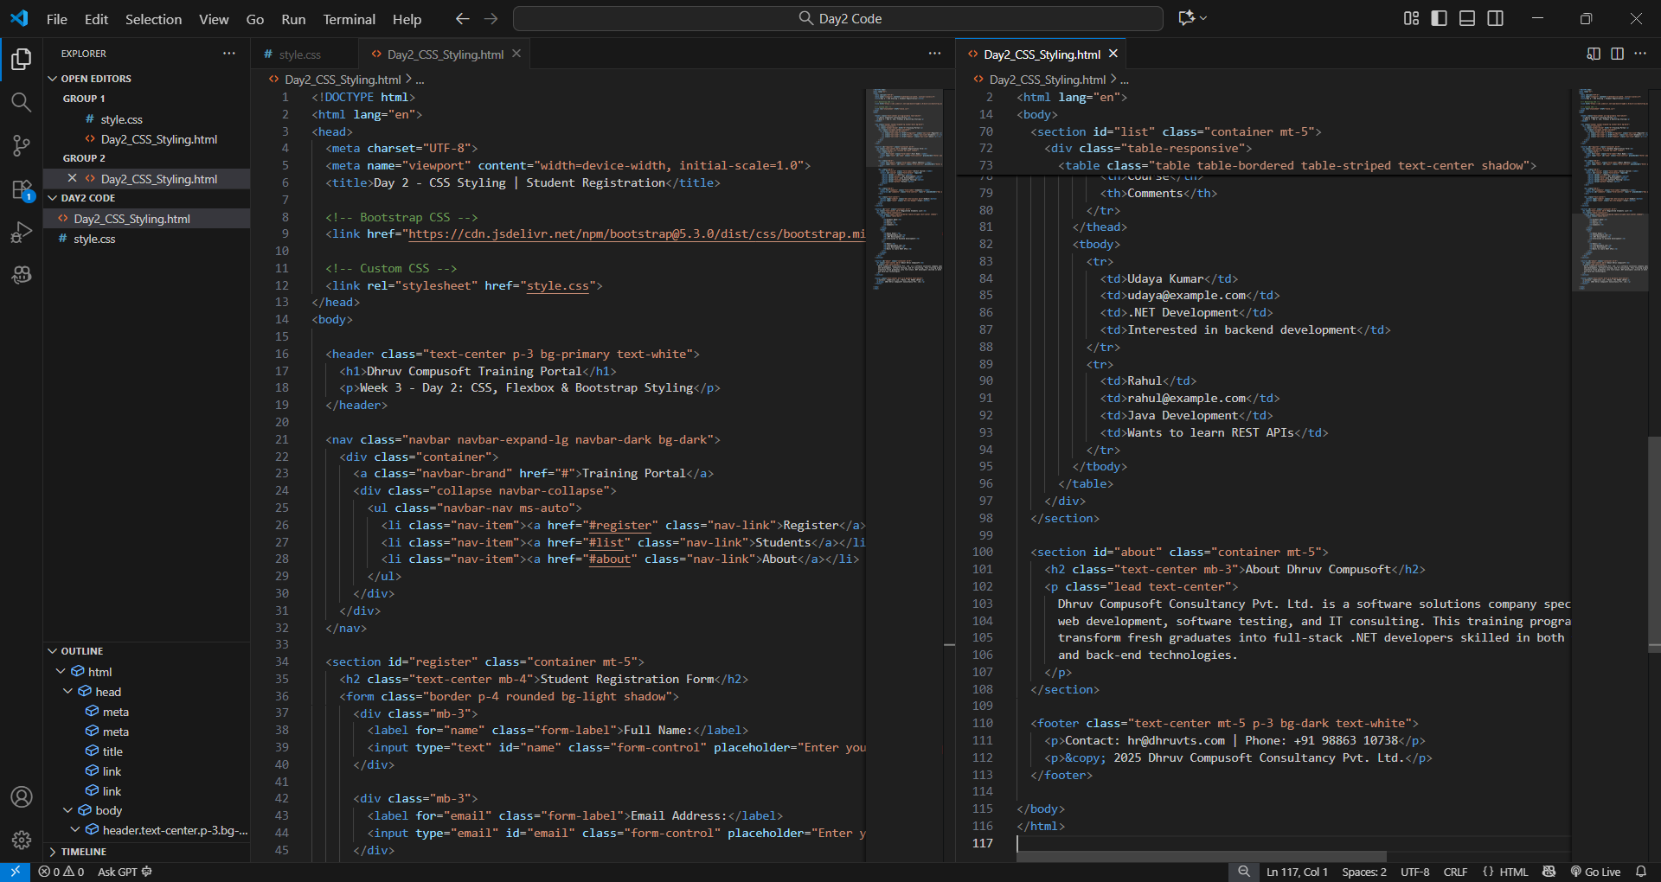

Code : Day2_CSS_Styling.html

Code : style.css

Output : Day2_CSS_Styling.html **and** style.css